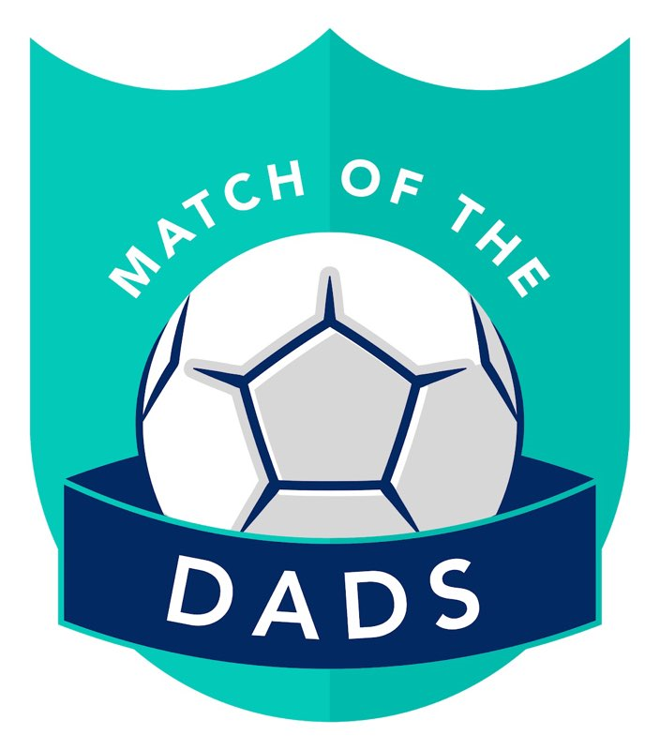

Match of the Dads: Season 4 (2019-20)

Rules and Regulations

Contents:

Page 1 – League and Match Information

Page 2 - In-Game Rules and Referee Responsibilities

Page 3 - Player and Captain Responsibilities

Page 4 – Payment Information

Page 5 – End of Season Awards

Page 6 – Personal Information (to be returned by all players to matchofthedads@outlook.com)

Rules, Regulations & Information

League Information
- Match of the Dad’s (MOTD’s) is a friendly Dad’s 5-a-side football league with the aim of giving Dad’s the chance to be social, have some fun and keep fit whilst raising money for Male Suicide Prevention charity CALM (Campaign Against Living Miserably).
- The league is run by a board consisting of Paul Godfrey (CEO), Adam Kemp and Tom Harber (Directors) and assisted by team captains Anthony Ashton, Michael Kelleher, Mark Marshall, Jason Pullen, Chris Rivett, Andrew Smith and Nick Taylor.
- All matches will be played at Goals, Hall Road, Norwich NR1 2GB and kick off will be at 19:30, 20:00 or 20:30 unless otherwise stated. See fixture list for details. Each match consists of two 28 minute halves with a 4 minute break for half time where the teams switch ends.
- Please make every effort to ensure you arrive at least 15 minutes prior to kick-off to ensure a prompt start. Matches will not be delayed to account for any lateness.
- Match fees are to be paid into the MOTD Bank Account by 20:00 the Friday prior to matchday. Failure to reach this deadline results in inability to play in that match.
- Any language, action or behaviours that are deemed inappropriate either on or off the pitch may result in your immediate expulsion from the league.

Match Information

- Matches will either kick off at 19:30 and finish at 20:30, 20:00 and finish at 21:00, 20:30 and finish at 21:30 as stated on the fixture list.
- Substitutions will take place at 7-minute intervals throughout each half and must be adhered to by each player in turn (the only exception to this is injuries or red cards) and will commence during the next applicable break in play.
- Teams must be able to field a match day squad containing at least 6 players for every game otherwise they will forfeit the match and concede a 12-0 loss.
- Each match will require teams to submit their squad with a minimum of 5 of their 7 team members committed to playing in the fixture. The Squad Submission deadline is 8pm on the Friday prior to match day. If a team cannot field a minimum number of 5 squad players before the squad submission deadline for their side they will automatically concede a 12-0 loss. Matches will not be rearranged unless in exceptional circumstance (majorly adverse weather etc).
- At the choice of the Captain, if players are unable to play a fixture then a team may apply for 1 loan player to ensure a minimum team of 6 so that the team contains one sub.
- If a player pulls out of a fixture after the deadline due to genuine emergency (birth of child, medical emergency etc.) a further emergency loan player (a maximum of two in total) can be requested.
- Loans cannot play in multiple games on the same night or play back to back weeks unless absolutely necessary.
- Team captains are able to apply for loans on a first come first served basis to the pool of players in the MOTD’s Reserves chat. Pre-agreed loans of players, players swapping teams or players sourced from outside the MOTD’s group are not permitted. Loans will be sourced from the reserves list prior to being opened to the main group if required.
- If a player is injured and/or due to miss a number of games, a reserve player can be signed to fulfil those fixtures and will therefore, for the purposes of selection, count as a squad player temporarily until the team member returns. The reserve player would then return to the reserves.

Referee

- Referee’s are essential for each game and their decision is final.
- Foul and abusive language towards the referee’s will not be permitted and could result in your immediate expulsion.
- If your team wish to contest a decision, the Captain or Vice Captain ONLY may speak to the ref.
- Referee’s are to be impartial and endeavour to enforce these rules.
- The ref will be awarded £5 paid into their account the day after the fixture is completed.
- Refs will be provided with a Ref Sheet prior to kick-off on which they must keep score by marking the minute in which a player has scored.
- Refs will be provided with the MOTD’s cards, whistle and clipboard.
- The ref is to check and ensure players are wearing appropriate footwear and shin pads prior to kick-off. Those contravening the rules will be unable to take to the field of play.
- Refs will be requested if required in the run-up to the next event and will be awarded on a first come first served basis. Anyone belonging to Match of the Dads is eligible.
In-Game Rules
- No drop kicks by Goalkeepers are permitted.
- No slide tackles are permitted.
- The keeper is not allowed to handle a direct back pass unless the pass has touched the back or side boards (so as the pass is not direct).
- No outfield players can intentionally enter the goalkeeper’s area and the goalkeeper cannot exit the area in order to gain an advantage (such as a player running through the area to get to the ball quicker, or the a keeper exiting his area to make a save). If an offensive player enters the area and gains an advantage then play restarts with a freekick in the area to be taken by the goalkeeper. If a defensive player enters the area or the goalkeeper leaves the area and gains an advantage then a penalty will be awarded to the opposition. However, where momentum carries a player into or out of the area but no advantage is deemed to have been gained then no punishment will be deemed necessary.
- Red and Yellow cards will be issued for dangerous and unsporting play or repeated offences:
  - Yellow card = At least 7 minutes cooling off on the touchline.
  - Red card = no further involvement in that match. The incident will be reviewed by the board with the possibility of a ban.
  - Any incidents in a game can be reported and/or can be reviewed by the board with retrospective action possible.
- Substitutions are unlimited as roll on/off but can only occur when the referee has stopped play. At least 7 minutes must have passed since the last substitution stoppage. The ref can only stop the game during a break in play such as the goalkeeper having possession of the ball, or when a free kick or penalty has been awarded.
- Teams are required to make substitutions to ensure everyone has a fair amount of game time and players must be subbed in turn. If a player would like a longer break they can opt to not return to the field of play should they wish. In the case of injuries a sub is allowed to replace the injured player(s).
- In the event of a team only fielding 5 players they will have no subs. If injuries occur the team will be expected to complete the fixture with their remaining players.
- Goalkeepers are not allowed to be subbed if a penalty is awarded unless the goalkeeper has been shown a yellow or red card, or is injured, and must leave the field of play.
- The ball must be returned to the centre spot after each goal is scored and all players must be in their own halves. Play can restart on the refs whistle.
- All free-kicks awarded can be either direct or indirect at the refs decision. Opposing players must be at least three strides away or as far as possible if near the goalkeeper’s area. The referee will measure and instruct where the defensive player is to be stood.
- Penalties must be taken with a one-stop run up.
- All players must wear MOTD’s squad shirts as well as shin pads and appropriate footwear. No screw in studs or blades are permitted, Astro Boots or Moulded Studs only. Outfield shirts are £10 inclusive of printing, GK shirts are £22 inclusive of printing. Requests to go via Paul Godfrey for ALL shirt orders. Payment made to the same account as match fees.
Player Responsibilities
- At the start of each season, players must complete and return the MOTD’s Personal Information Sheet.
- Players must opt-in to each match by accepting their invite on the MOTD’s Facebook group to each event and paying their match fee ahead of the Friday 8pm Squad Submission Deadline. Failing to do so will result in a strike and the inability to feature in that game.
- Players must make their captain aware of any reason for absence in suitable time to allow loan cover as replacement if necessary.
- Players who have opted in but drop out after the payment deadline will lose their match fee. A loan player can still be drafted in to replace the player.
- Players who are unresponsive to event invitations or do not attend when they have opted-in will receive a strike (unless they have made their captain’s aware with reasonable time to find a replacement).
- Any player to receive 3 strikes will be reviewed by the MOTD’s Board with the possibility of being removed from the MOTD’s group or moved to the Reserves.
- MOTD’s reserves the right to remove any player with immediate effect should their conduct be deemed severely inappropriate or if rules are repeatedly contravened.

Captains Responsibilities

- Each team will have a Captain, they are your main point of contact.
- Captains are required to manage their teams needs and requirements throughout the season
- Ensure reminders are sent out to their team regarding payment and confirmation of attendance on Facebook match events before each 8pm deadline.
- To submit their team prior to the 8pm Friday deadline, and ensure loan players are sourced as required to fill gaps.
- Addressing any issues players have with Match of the Dads with the board.
- Refereeing games at least once per month.
- Taking the kit bag home at least once per month and washing the bibs ready for the next round of matches.
- To be responsible for the conduct of their players on the pitch, and ensuring only the Captain approaches the referee to discuss in play decisions on behalf of their team.
- Taking part in the match of the Dads podcast when required.
- Attending captains meetings when required.
- Appoint a Vice Captain to carry out these requirements in the Captains absence.

Payment Information

The MOTD pricing structure for Season 4 (June 2019 – May 2020) is as follows:

14 Players:
£35.00 Pitch Hire
£5.00 Referee Payment
£16.00 Charitable Donation
£56.00 Total Match Cost

£56.00 / 14 = £4.00 each per match

12 Players:
£35.00 Pitch Hire
£5.00 Referee Payment
£8.00 Charitable Donation
£48.00 Total Match Cost

£48.00 / 12 = £4.00 each per match

- Regardless of whether we have 14 players or 12 players the match fee will be £4.00 each.
- Players have the option of paying for several matches as a lump sum should they wish.
- Payment is to be made into the MOTD Bank Account by 20:00 on the Friday prior to match day to give admin enough time to forward the pitch hire money on to Goals.
- The bank details for the MOTD Bank Account are:
  - Sort Code: 30-96-17
  - Account: 16971360
  - Name: Godfrey
- Please ensure you use your squad number and surname as the reference to enable us to reconcile the account.
- We as admins cannot afford to fund this league so it is as simple as “You don’t pay, you don’t play”. All monies are to go through the MOTD Bank Account and cannot be paid on the night.
- Every match you will also be contributing towards our partnered charity “CALM -The Campaign Against Living Miserably” who do a lot of great work in the line of male suicide prevention.

End of Season Awards
At the end of the season we shall be awarding 10 trophies, they are:
- Golden Boot - Awarded to the player who scores the most league goals.
- Golden Glove - Awarded to the goalkeeper who has the lowest goals conceded per game.
- Dad of the Season - Awarded to the Dad who wins the most Dad of the Match Awards
- Goal of the Season - Awarded to the goalscorer who is voted as the goal of the season.
- Clubman - for that one player who goes above and beyond for the cause. Everybody will get one vote and this vote should go to the players who encapsulates the spirit of MOTD’s
- Players Player - By player vote, goes to the est player across the course of a season.
- League Champions - Awarded to the Match of the Dads League Champions
- Cup Winners - Awarded to the Match of the Dads Cup Winners
- Most Improved - Awarded to the player who has improved the most over the season.
- Best Newcomer - will be awarded to the best newcomer who is in their first full season.

Please note, all awards require at least 5 appearances to qualify. For Golden Boot and Glove, only squad players are eligible and only goals scored/conceded for their own squad will count. All other awards can be won by squad or loan players.

Personal Information

Squad Number………………………………………………………………………………………………………………………………………………

Name…………………………………………………………………………………………………………………………………………………

Address………………………………………………………………………………………………………………………………………………

Email………………………………………………………………………………………………………………………..…………………………

Mobile Number……………………………………………………………………………………………………………………………………………..

Emergency Contact Details:

Emergency Contact Name…………………………………………………………………………………………………………………….…………………………….

Emergency Contact Telephone Number……………………………………………………………………………………………………...……………………………………….

Medical Information (any relevant medical conditions or allergies):

……………………………………………………………………………………………………………………………………………………………

……..…………….......……………………………..…………………………………………………………………………………………………

………………………………………………..............................................................................................................

Signature of acceptance:

Please sign and date below to confirm your acceptance of the rules and regulations laid out in this document and then return at your earliest convenience via matchofthedads@outlook.com

Sign……………………………………………………………………………………………………………………………………………………..

Date…………………………………………………………………………………………………………………………………………………….

